**Increasing the disk with LVM in RedHat 7.8**

**Issue Definition:**

Unable to extend the partition in the OS system (Redhat) through this link.

<https://docs.microsoft.com/en-us/azure/virtual-machines/linux/resize-os-disk-gpt-partition>

**RCA:**

Since the **growpart** could use when the partition is the last partition in the disk, but the sda4 is not the last partition. So that is why we could not directly resize the partition using growpart command.

**Have done:**

* We checked the partition status in the OS system, and found there are 5 partition in the OS disk.

[root@prddmzc1dwebsiteapp01 
Isb1k 
SIZE RO 
NAME 
fdO 
s da 
Hsdal 
h—sda2 
Hsda3 
I—sda4 
I Brootvg—tmplv 
—usrlv 
I I—rootvg 
—opt Iv 
I Frootvg 
—homelv 
I I—rootvg 
—varlv 
I crootvg 
—rootlv 
Happvg—loglv 
L—appvg— code Iv 
s db 
L—sdbl 
MAJ:MIN 
253:2 
253:3 
253:4 
253:5 
253:6 
253: 7 
253:0 
253: 1 
8:16 
8:17 
1 
o 
o 
o 
o 
o 
o 
o 
o 
o 
o 
4K 
256G 
500M 
500M 
2M 
63G 
IOG 
18G 
36G 
IOG 
64G 
64G 
O 
O 
0 
O 
O 
O 
O 
O 
0 
O 
O 
O 
O 
TYPE 
disk 
disk 
part 
part 
part 
part 
1 vm 
1 vm 
Ivm 
Ivm 
Ivm 
part 
Ivm 
Ivm 
disk 
part 
MOUNTPOINT 
/ boot/efi 
/ boot 
/ tmp 
/usr 
/ opt 
/home 
/ var 
/ log 
/ code 
/ mnt 

* Since the partition of sda4 is not the last partition, so we could not directly resize the partition.
* We want to extend the volume group (rootvg) size, so we could add a new extend partition and add this partition in the volume group.

**How to add the available space in the volume group.**

1. Please create a new partition in the disk. After create the partition, enter ‘w’ to save the partition.

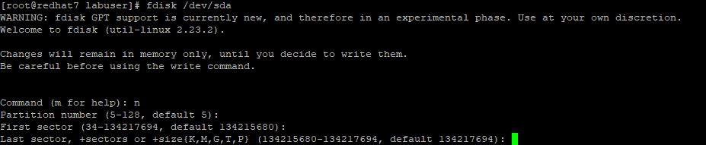

1. Update the disk partition status to the kernel.

             partprobe /dev/sda

1. Create the physical volume.

pvcreate /dev/sda6

1. Running vgdisplay to know the volume group name.

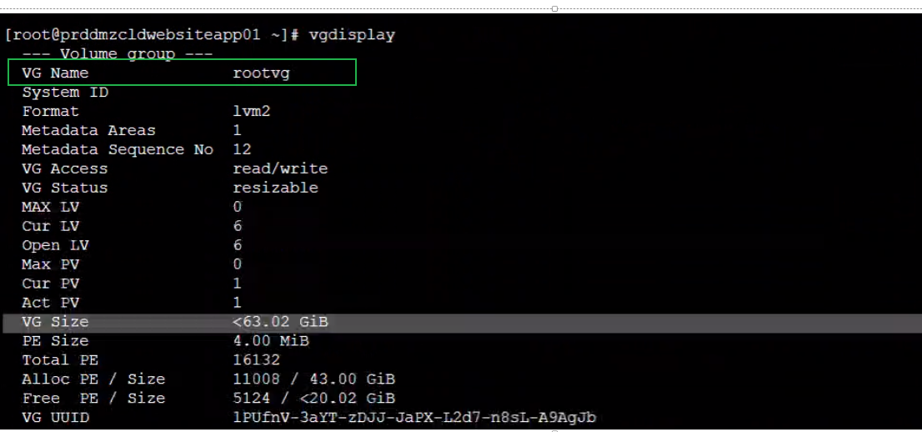

1. Add the physical volume to the VG.

              vgextend rootvg /dev/sda6

1. Running vgdisplay -v to know the logical volume name.

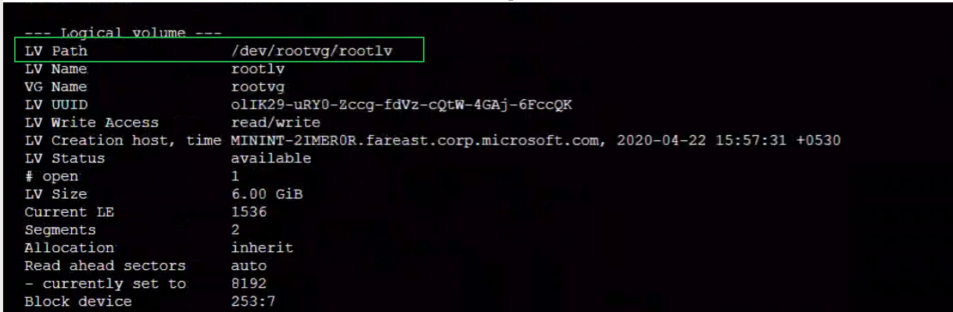

1. Determine which logical volume you want to resize and extend the logical volume size.

              lvextend -L+3G /dev/rootvg/varlv

1. After we resize the logical volume, please update the volume status.

If the file system is XFS. Please run   xfs_growfs /dev/rootvg/varlv

If the file system is ext4, please run resize2fs /dev/rootvg/varlv

1. After we finished these operations, please using df -h or lsblk to check the logical volume size.